**TEMASEK POLYTECHNIC**

**SCHOOL OF INFORMATICS & IT**

**DIPLOMA IN INFOCOMM AND DIGITAL MEDIA**

**ICT SYSTEMS, SERVICES & SUPPORT**

**VIRTUAL DESKTOP TECHNOLOGY (VRDT) CIML015**

**AY 2024/25 OCTOBER SEMESTER**

**PROJECT**

|  |
| --- |
| **Date:**  **“By submitting this work, I am / we are declaring that I am / we are the originator(s) of this work and that all other original sources used in this work has been appropriately acknowledged.**  **I / We understand that plagiarism is the act of taking and using the whole or any part of another person’s work and presenting it as my/ our own without proper acknowledgement.**  **I / We also understand that plagiarism is an academic offence, and that disciplinary action will be taken for plagiarism.”**  **STEPS ID:**  **………….…**    **NAME AND SIGNATURE OF STUDENTS: ………….… ……………** |

Table of Contents

1.0 Introduction 3

2.0 Introduction of Virtual Desktop Infrastructure (VDI) 5

3.0 Products selection of VDI 8

4.0 Comparison of the changes after implementing cloud 11

5.0 Total Cost breakdown 13

6.0 References 16

**Project Report – 30%**

**Requirement: At least 20 page or above.**

**Introduction** – Background, Aim and Purpose of this Proposal

**Intro and Background:**

You are working in an IT department of a Software Training School, Macro Soft and it has 6 branches in Southeast Asia. It is estimated they have

**Current Enviroment:**

Management and Admin Staff – 25;

• IT Support Staff – 20;

• Instructors – 35;

• Student Developers – 800.

Currently, the instructors and students are provided with Windows 10 or Ubuntu OS that runs the following applications:

1) Libre Office Suite

2) Chrome Browser

3) Zoom

4) Sublime Text IDE

**Problem statement:**

The staff travel frequently within all the branches in Southeast Asia. The classes can be ad-hoc and dynamic, conducted face to face or online. The IT support staff need to be able to set up the training environment in a short time. Often instructors and students complained about the lack of technical support and slow in response, when their notebook or applications failed. This causes undue stress for the instructors and bad learning experience for the students.

**Tasks assigned by Manager:**

Your Manager is thinking of providing some Virtual Desktop with the necessary applications pre-installed as a temporary replacement measure to deal with the notebook or application failure issue. You are requested to write and present a proposal to your manager on such solution.

**Design -** With reference to the above scenario, report on the Virtual Desktop solution for

1. Compute

* vCPU
* RAM

1. storage and network requirement;

* Root Volume – Stores installed apps and windows/linux OS
* User volume – Holds documents, Personal files and user profiles
* Customizable – When creating or rebuilding a workspace, you can set up both sizes
* Expansion – Users that save more data can benefit from storage auto-expansion, Which is accessible if enabled
* Persistent – User information endures even in the event that workspace terminates or reboots

b. Costing;

c. Pros and Cons;

Product selection – >

AWS Workspace

Design diagram – >

On Premises

Public Cloud

Hybrid

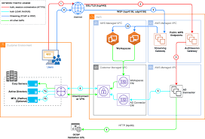

**Description Product & design Core components**

1. Citrix Netscaler Load balancer

* Multiple specialized services, such as load balancing
* Gateways for custom authentication
* Portals for applications
* Web-based, secure gateways to AWS resources

1. Citrix Storefront

* Citrix storefront is not an AWS Workspaces solution, It is a citrix technology
* Citrix storefront and AWS workspaces are not natively integrated
* Citrix virtual apps and desktops, not AWS Workspaces, are what storefront is intended to deliver

1. XenDesktop controller

* Citrix virtual desktops(Citrix VDI solution) are controlled by XenDesktop(Citrix DDC)
* Amazon’s managed VDI offering is called AWS Workspaces
* AWS Workspaces and citrix delivery controllers are not directly related
* AWS Workspaces cannot be managed from a citrix DDC

1. Citrix studio

* The citrix virtual apps and desktops(formerly knows as XenApp/XenDesktop) control console is called citrix studio
* Citrix is not the basis for AWS Workspaces
* AWS Workspaces cannot be managed with citrix studio

1. License server

* One completely managed VDI service is AWS Workspaces
* Installing and maintaining a license server is not necessary for AWS, unlike Citrix or Microsoft RDS systems
* As a component of the workspaces service, AWS manages licensing internally for you

1. Cirtix Director

* Citrix Director is not compatible with AWS Workspaces directly
* Citrix director is designed specifically for citrix environments
* AWS Workspaces uses its own set of monitoring tools via the AWS Management console, CloudWatch, and WorkSpaces-specific APIs.

1. Pooled desktops (Windows pool or Linux Pool)

8) Database (MSSQL)

9) 02x 10GB Network switches (Cisco Nexus, Dell Sforce)

10) 01x SAN storage (Dell MD, Dell EMC unity, HP , Lenovo)

11) 18x Citrix Xenserver Hypervisors

**Capacity sizing and Costing;**

Task workload is for students = 800

Knowledge workload is for Staff = 80

Storage calculation:

800 students x 20GB = 16TB

80staff x 30GB = 2.4TB

Total storage = 18.4TB (20TB) RAID6

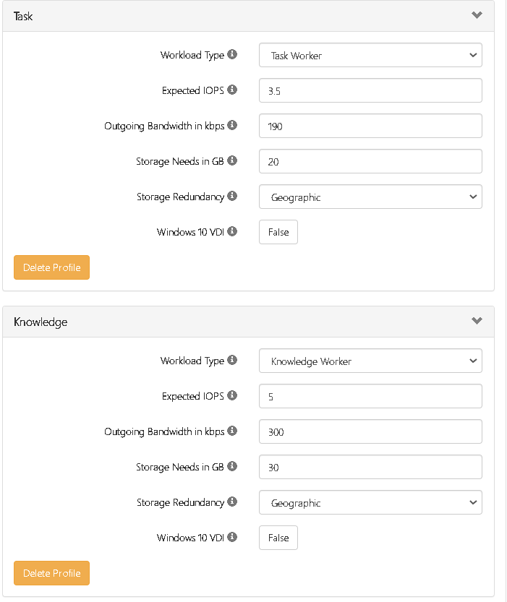

**Total cost for project:**

USD $51k x12months = $612K per year (Example)

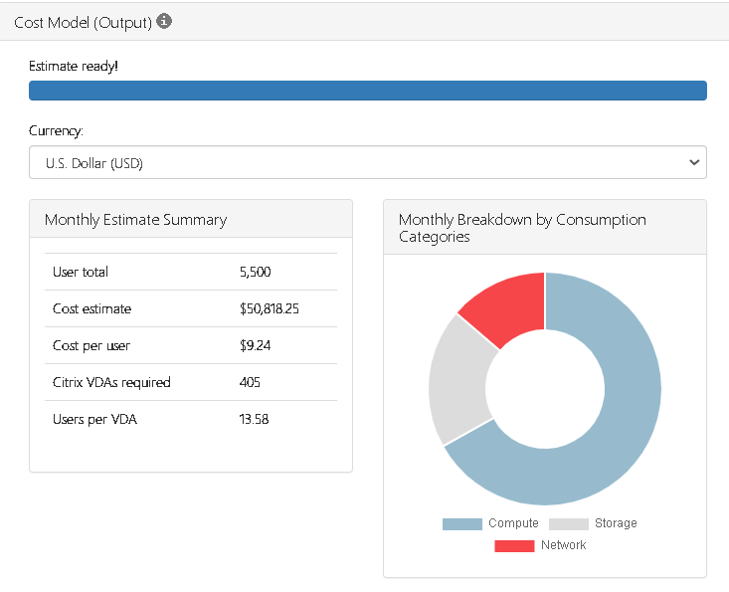

**Pros and Cons:**

# 6.0 References